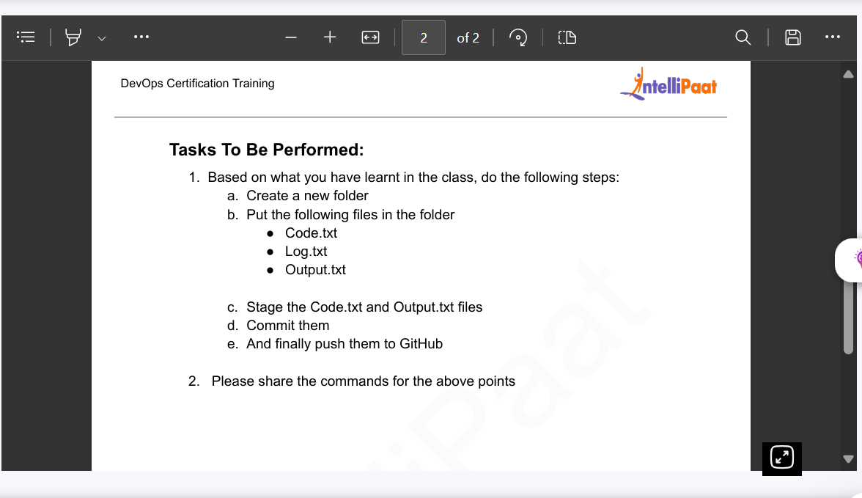

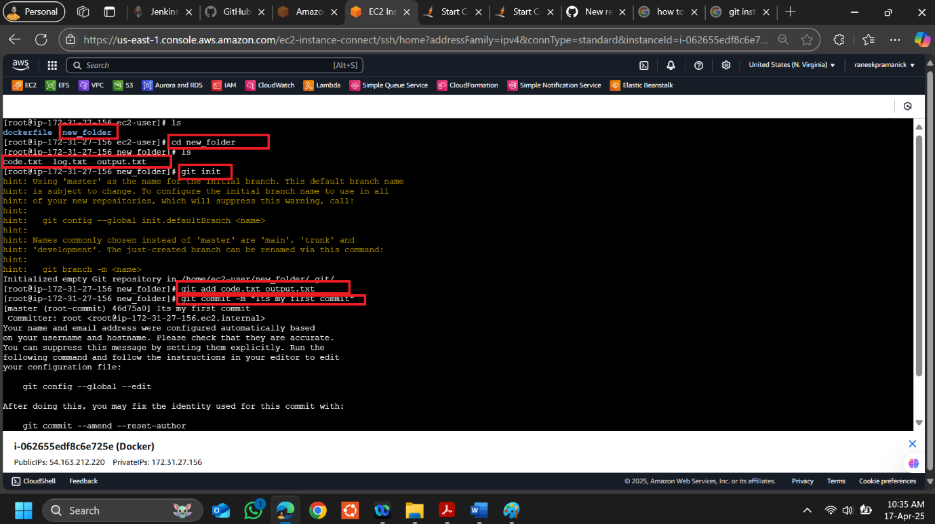

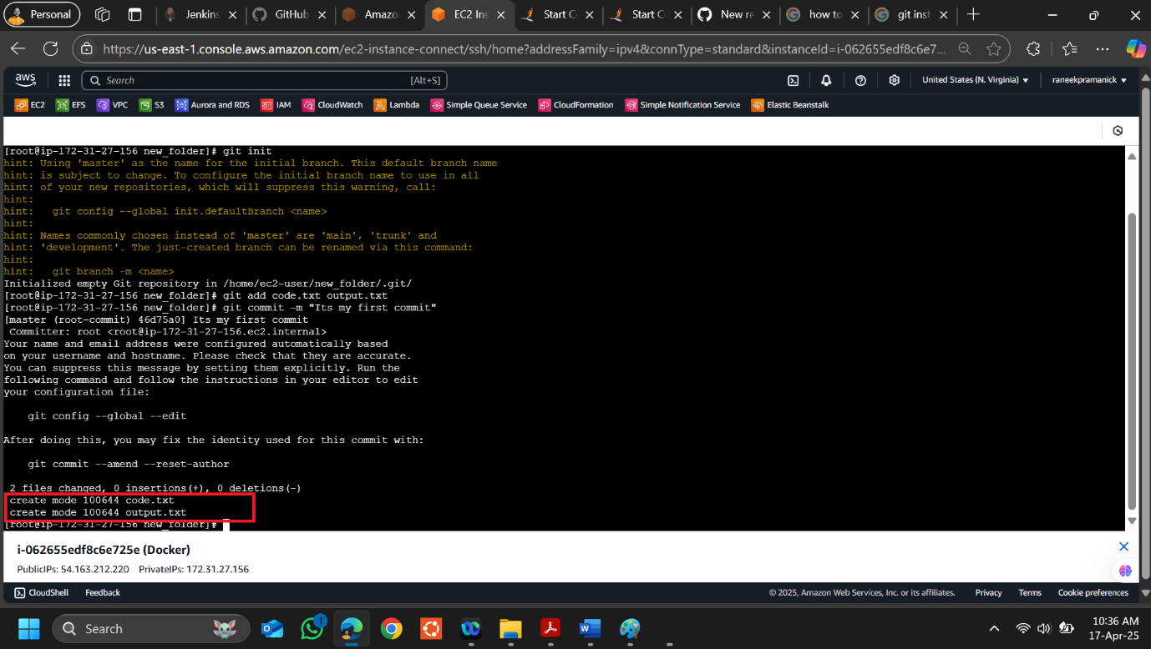

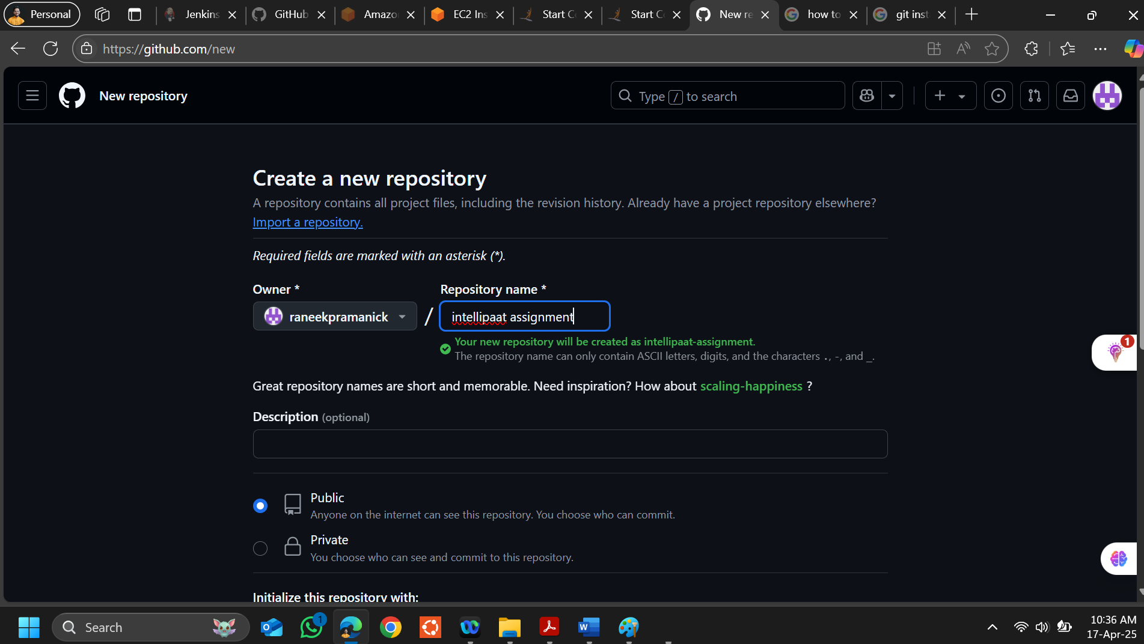

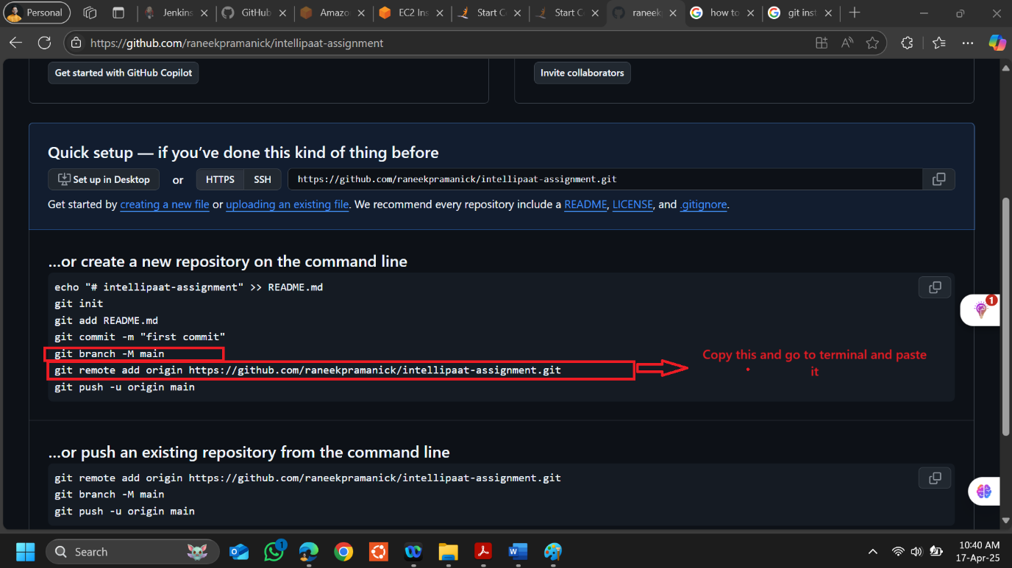

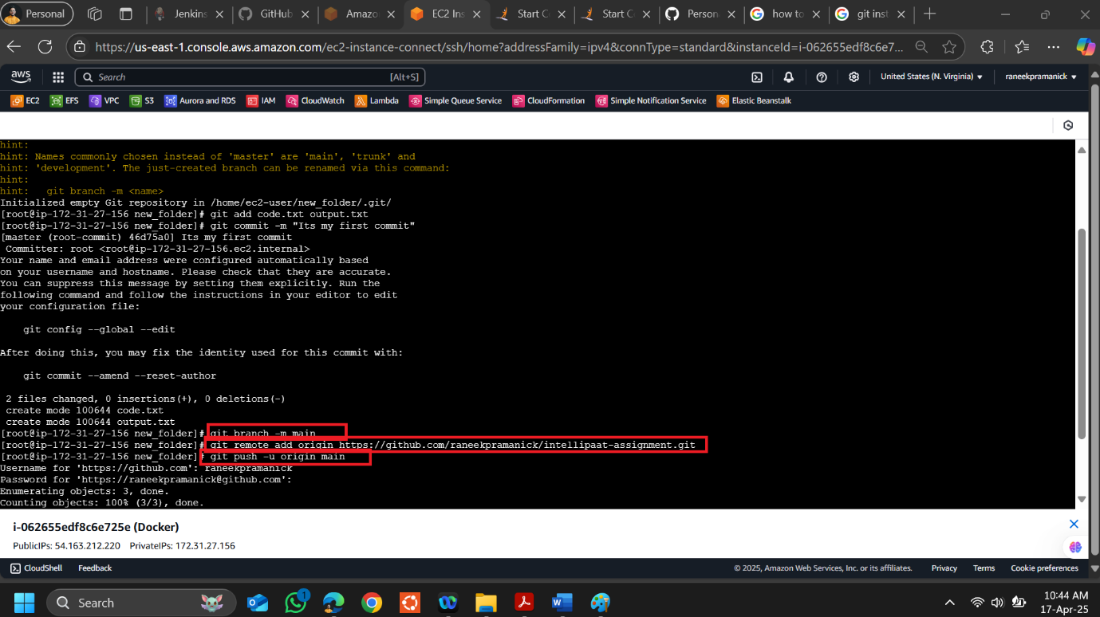

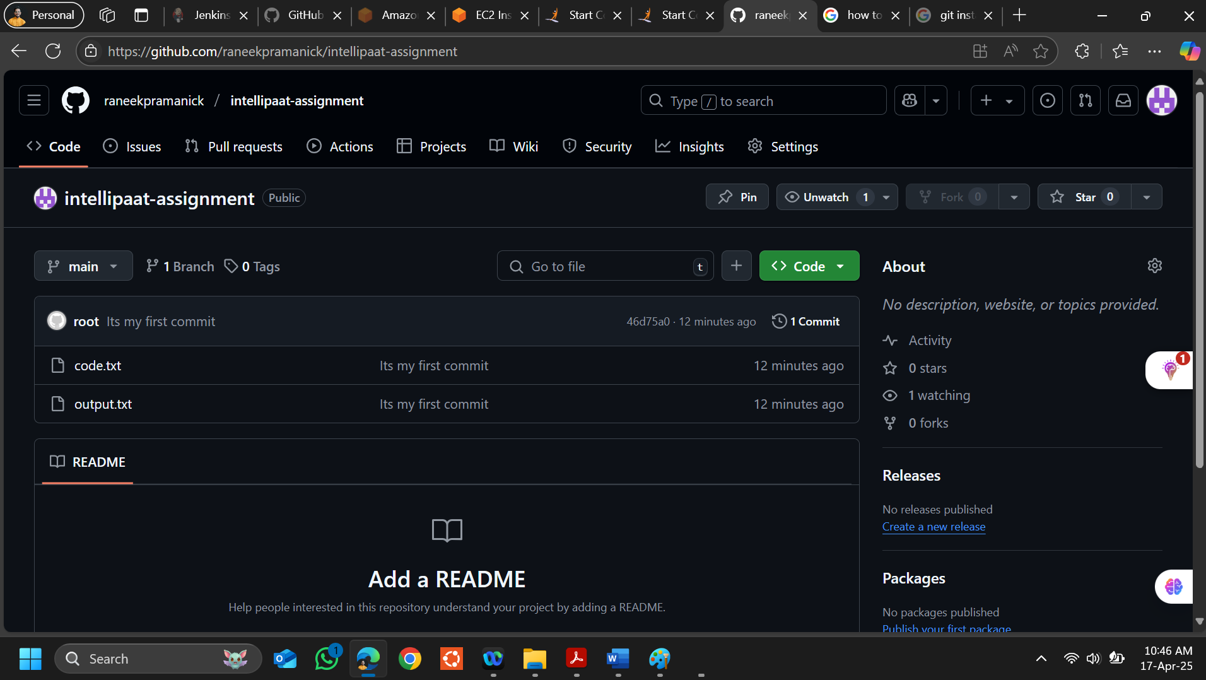

**Please find the command of the assignment below-**

sudo yum update

sudo su

yum install git

mkdir new_folder

cd new_folder

touch Code.txt Log.txt Output.txt

git init

git add Code.txt Output.txt

git commit -m "Its my first commit"

git branch -m main

git remote add origin <repository-url>

git push -u origin main